**Paper Title - The First Letter of Each Word is Capitalized**

Author Name Surname 1*[0000-0000-0000-00000] and Author Name Surname 2[0000-0000-0000-00000]

1E-mail address, Affiliation

2E-mail address, Affiliation

**Abstract**

A concise and informative abstract must not exceed 250 words in length for full papers. If only an abstract will be submitted, it must have at least 250 words but not exceed 1 page in length. Abstracts must summarize the purpose, methods and major findings of the paper. The paper must have minimum 3 and maximum 5 keywords which must be sorted in alphabetical order and separated by comma. Figures and tables must not be given in Abstract.

**Keywords.** Keyword-1, keyword-2, keyword-3, keyword-4, keyword-5

1. **Introduction (Heading 1)**

This template has been designed for preparing a paper for International Conference on Advances in Engineering, Architecture, Science and Technology 2021 (ICA-EAST 2021).

The language of the papers and presentations are English. The digital copy of the manuscript, prepared by Microsoft Word or LaTeX, together with original figures and tables must be submitted to the journal only via e-mail (ica-east@erzurum.edu.tr).

After the submission, the manuscripts will be edited according to the proceeding submission format and authors may be requested for some corrections or for addition of any missing information. All papers will be blind reviewed and assessed by two referees.

Both categories of papers must use the instructions described in this template. Authors, for whose English is not the native language, are strongly encouraged to have their manuscript carefully edited prior to submission. Also, authors are recommended to perform spell checking of the paper.

**Abstract.** Abstracts must have 250 words at least and may have up to 1 page. The accepted abstracts will be published in the proceedings of the conference. The review process consists of two steps: (1) accept, reject, or accept with changes by a review committee of 2 experts; (2) accept or reject of changed paper by the conference organizers.

**Full Papers.** Full papers describing outcomes of substantive research may have 4 to 9 pages. The accepted full papers will be published in the proceedings of the conference. The review process consists of two steps: (1) accept, reject, or accept with changes by a review committee of 2 experts; (2) accept or reject of changed paper by the conference organizers.

1. **General Format Rules**
   1. **Page Format (Heading 2)**

The paper will be used in proceedings book is A4 (210 x 297 mm). Page margins must be set as specified in Figure 1.

The first page of the paper must be on an odd page.

* 1. **Fonts, Line Spacing and Paragraph Format**

Throughout the paper, Times New Roman font must be used except program code. However, the font type and size may change due to the text purpose and hierarchy (Table 1).

The main text body must be written with regular (non-italics and non-bold) characters. All titles and headings in the paper must be bold and first letters should be written capital. Italic characters must be used only when necessary (Nouns in Latin, abbreviations, theories/definitions, quotations, etc.).

One space distance must be placed after the commas and full stops.

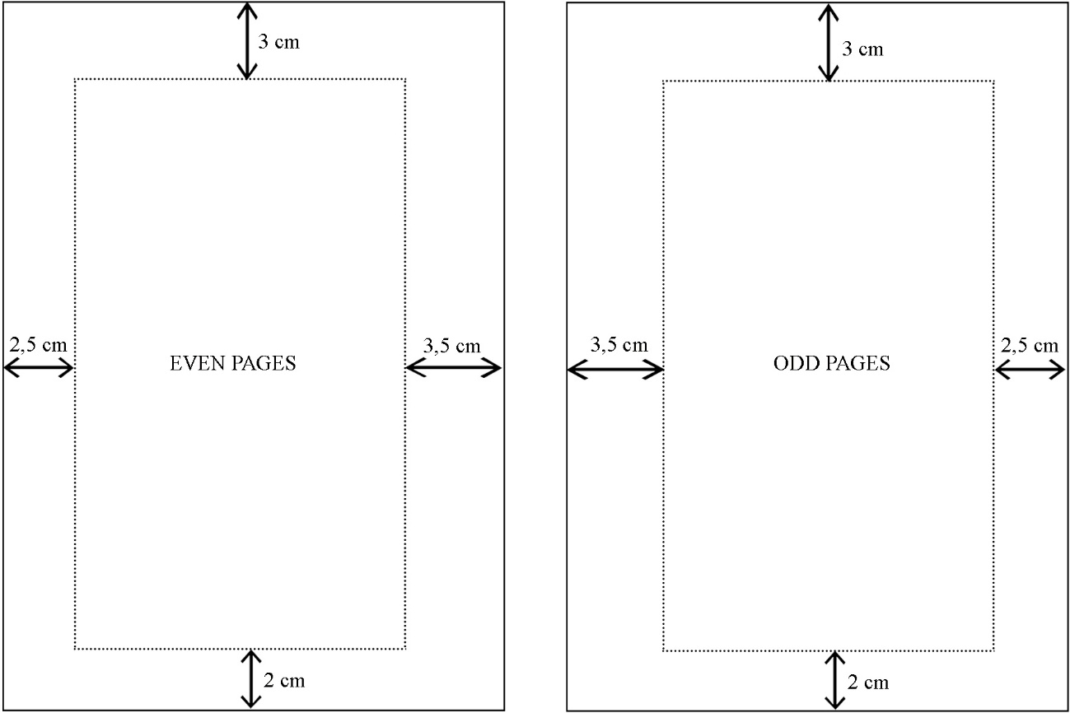

**Figure 1:** Page Margins.

Headings must not be the last line of a page, a title must be placed on the following page unless two more lines could be written after it. The first line of a paragraph cannot be the last line of a page, as the last line of a paragraph cannot be the first line of a page (termed as widows and orphans).

All headings must be numbered consecutively and hierarchically.

**Table 1:** Text Formatting Guideline.

|  |  |  |  |  |  |  |
| --- | --- | --- | --- | --- | --- | --- |
|  | **Font** | **Size** | **Style** | **Line**  **Spacing** | **Paragraph**  **Spacing** | **Justification** |
| **Paper Title** | Times New Roman | 16 | Bold | 1 | 0 – 16 pts | Centered |
| **Heading 1** | Times New Roman | 12 | Bold | 1 | 16 – 8 pts | Aligned |
| **Heading 2** | Times New Roman | 10 | Bold | 1 | 16 – 8 pts | Aligned |
| **Main Text** | Times New Roman | 10 | Regular | 1 | 6 – 6 pts | Aligned |
| **Figures and Table Caption** | Times New Roman | 10 | Mixed | 1 | 12 – 6 pts | Centered |
| **Figure and Table Text** | Times New Roman | 8-10 | Mixed | 1 | 6 – 6 pts | Aligned |
| **Quotations** | Times New Roman | 10 | Italic | 1 | 6 – 6 pts | Aligned |
| **Program Code** | Calibri Light | 10 | Regular | 1 | 6 – 6 pts | Aligned |
| **Footnotes** | Times New Roman | 8 | Regular | 1 | 6 – 6 pts | Aligned |

* 1. **Page Numbering**

All of the pages must be numbered. Page numbers must be placed at 10 mm above the bottom of the page, in the direction of reading. The font style used throughout the paper must be used for page numbers.

* 1. **Tables and Figures**

Tables and figures must be placed after they are first cited in the main text body, but must be as close as possible, in accordance with the rules in this guideline. All tables and figures must be cited before they are used in the main text body and must be on the same page with their captions. Figures are to be numbered and to have a caption that is always positioned under the figures, in contrast to the caption belonging to a table, which should always appear above the table.

All tables and figures must be horizontally centered on the page and must be numbered consecutively (Figure 1, Figure 2, Table 1, Figure 3). For tables and figures spanning more than one page, the same number and caption must be written below the continued figure, with the expression “continued” added in brackets (i.e. Table 1 (continued): Table Name).

Figures and tables must be inserted in the document. Their widths must be 75 mm or 150 mm and heights should not exceed 150 mm. Every images used in paper must have 300 dpi minimum and preferably submitted as tiff or jpeg formats. It is essential that all illustrations are as clear and as legible as possible. Vector graphics – instead of rasterized images – should be used for diagrams and schemas whenever possible. Please check that the lines in line drawings are not interrupted and have a constant width. Grids and details within the figures must be clearly legible and may not be written one on top of the other.

* 1. **Equations**

Equations must be written according to the rules specified below, using an equation editor.

Equations must be horizontally centered on a page. Number equations consecutively. Equation numbers, within parentheses, are to position flush right, as in (1), using a right tab stop.

x + y = z (1)

Displayed equations or formulas are centered and set on a separate line. Displayed expressions should be numbered for reference. The numbers should be consecutive within the contribution, with numbers enclosed in parentheses and set on the right margin.

* 1. **Abbreviations and Acronyms**

Define abbreviations and acronyms the first time they are used in the text, even after they have been defined in the abstract.

Abbreviations such as IEEE, SI, MKS, CGS, sc, dc, and rms do not have to be defined. Do not use abbreviations in the title or heads unless they are unavoidable.

* 1. **Footnotes**

Footnotes could be used in paper to add content-expanding, content-enhancing, or additional information.

Footnote numbers must be placed directly after a quotation. In case the quotation is a paragraph, the footnote numbers must be placed directly after the last word of the paragraph (as superscript). In case the quotation is a concept or a noun, footnote numbers must be placed directly after that concept or noun (as superscript). Footnote numbers in the main text body must be indicated as subscript1, as shown.

A punctuation mark must not be placed after the number. Footnotes must be written with a font size 2 pt smaller than the main text body font size.

* 1. **Program Code**

Program listings or program commands in the text are normally set in calibri light font:

Program commands

1. **Using the Template**

After the manuscript has been completed, the paper is ready for the template. First, confirm that you have the correct template for your paper size. This template has been tailored for output on the A4 paper size. If you are using US letter-sized paper, please close this file and download the Microsoft Word, Letter file.

The template is used to format your paper and style the text. All margins, column widths, line spaces, and text fonts are prescribed; please do not alter them.

1. **Conclusion**

After the acceptance of the manuscripts for publication, authors must send the final version of their manuscript and figures to the conference e-mail (ica-east@erzurum.edu.tr). It is the author’s responsibility to obtain written permission from authors and publishers of any previously published material; text, tables, figures, etc.

**Acknowledgements (if any)**

Acknowledgements of financial support, advice or other kind of assistance should be given at the end of the text under the text. The names of funding organizations should be written in full. If no acknowledgement is necessary, this section should not appear in the text.

This should always be a run-in heading and not a section or subsection heading. It should not be assigned a number. The acknowledgements may include reference to grants or supports received in relation to the work presented in the paper.

**References**

The references should be cited according to the Harvard Referencing Style.